SOFTWARE REQUIREMENTS SPECIFICATION

**For**

**Expense Tracker**

**Prepared by:-**

Ashwand Narayanan S

Hariharan P

Harreni R

# Introduction

## Purpose

The main objective of this document is to illustrate the requirements of the project js Expense Tracker. The document gives a detailed description of the both functional and non-functional requirements proposed by the client. The purpose of this project is to provide a friendly environment to maintain the details of expenses including income and expenditure records. The main purpose of this project is to manage expenditure and income. This project describes the hardware and software interface requirements using ER diagrams and UML diagrams.

## Document Conventions

* + - The entire document should be justified.
    - Convention for the Main title

Font face: Times New Roman Font Style: Bold

Font Size: 14

* + - Convention for Subtitle

Font face: Times New Roman Font Style: Bold

Font Size: 12

* + - Convention for body

Font face: Times New Roman Font Size: 12

## Scope of Development Project

Expense Tracker is a comprehensive expense management solution designed to streamline and enhance users' financial tracking experience. It offers secure registration, easy expense recording, dynamic categorization, analytics, budget management, and seamless accessibility across multiple platforms.

The application prioritizes data security, encryption, search and filter capabilities, notification systems, and export and import functionalities. It integrates with financial platforms for automated expense tracking and provides offline functionality. The application also includes a robust feedback mechanism and help section for user assistance. Legal compliance and user trust are prioritized, with clear communication of terms of use and privacy policies. The development process involves continuous collaboration with stakeholders, incorporating feedback, and adapting to evolving user needs.

## Definitions, Acronyms and Abbreviations

JAVA -> platform independence SQL-> Structured query Language ER-> Entity Relationship

UML -> Unified Modeling Language

IDE-> Integrated Development Environment SRS-> Software Requirement Specification

## References

* + - Books
* Building an Expense Tracker App with React Native" by Bruno Roch
* The Expense Tracker App: A Step-by-Step Guide to Creating a Mobile App for iOS and Android" by John Bura.
  + - Website

[**https://mint.intuit.com/**](https://mint.intuit.com/)

<https://www.ynab.com/>

# Overall Descriptions

## Product Perspective

Use Case Diagram of Expense Tracker

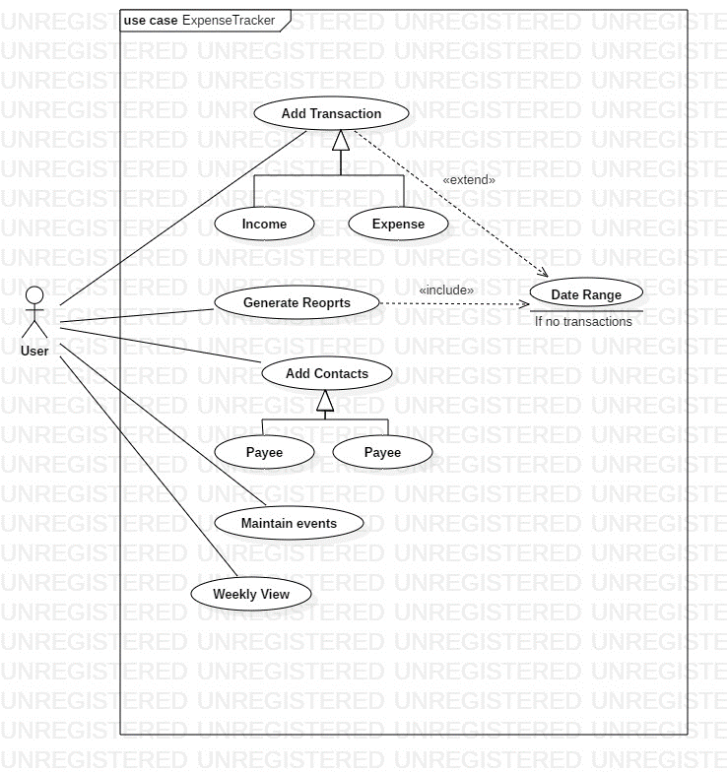

## Product Function

Entity Relationship Diagram of Expense Tracker

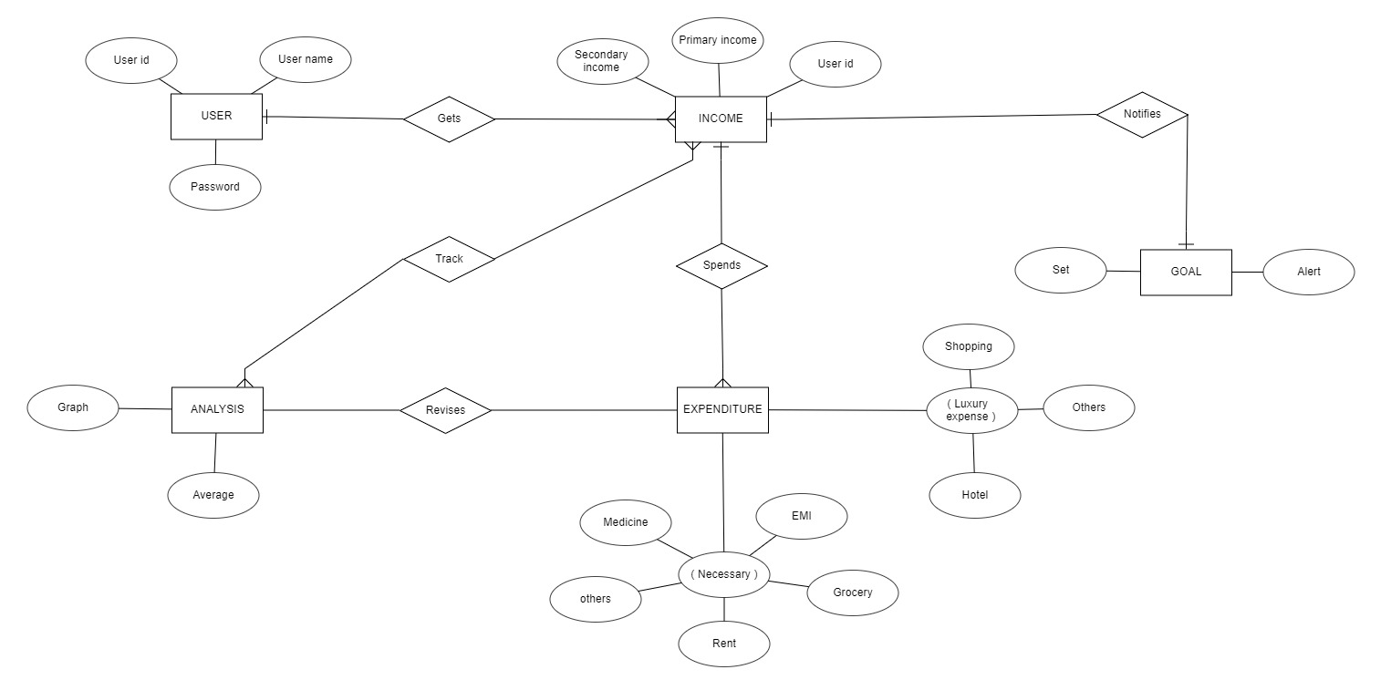

## User Classes and Characteristic

The system provides different types of services based on the type of users [Individuals/ Businesses]. This service offers comprehensive expense management solutions for individuals and businesses of all sizes, providing a personal finance management solution.

The features that are available to the Individuals are: -

* + - User-Friendly Expense Entry
    - Budget Management
    - Real-Time Expense Tracking
    - Mobile Accessibility
    - Expense Categories
    - Reminders and Notifications
    - Offline Mode

The features that are available to the Businesses are: -

* + - Multi-User Access
    - Customizable Expense Categories
    - Advanced Reporting and Analytics
    - Budget Forecasting
    - Security and Compliance

## Operating Environment

The Expense Tracker is a versatile expense tracking solution designed for various platforms, including desktop, mobile, and database management systems. It is compatible with popular web browsers and supports multiple languages and currencies. The software also ensures data security through robust encryption protocols. It’s hardware requirements are clearly outlined, and it supports third-party integrations, ensuring compliance with data protection laws. The system also prioritizes backup and recovery procedures, ensuring users' data is secure in case of system failures or data loss. Overall, the Expense Tracker is designed to adapt to diverse technological contexts.

## Assumptions and Dependencies

The assumptions are: -

* + - The coding should be error free
    - The system should be user-friendly so that it is easy to use for the users
    - The information of all users, books and libraries must be stored in a database that is accessible by the website
    - The system should have more storage capacity and provide fast access to the database
    - The system should provide search facility and support quick transactions
    - The Library System is running 24 hours a day
    - Users may access from any computer that has Internet browsing capabilities and an

Internet connection

* + - Users must have their correct usernames and passwords to enter into their online accounts and do actions

The dependencies are: -

* + - The specific hardware and software due to which the product will be run
    - On the basis of listing requirements and specification the project will be developed and run
    - The end users (admin) should have proper understanding of the product
    - The system should have the general report stored
    - The information of all the users must be stored in a database that is accessible by the expense tracker
    - Any update regarding the expense is to be recorded to the database and the data entered should be correct

## Requirement

Software Configuration: -

This software package is developed using java as front end which is supported by sun micro system. Microsoft SQL Server as the back end to store the database.

Operating System: Windows NT, windows 98, Windows XP Language: Java Runtime Environment, Net beans 7.0.1 (front end) Database: MS SQL Server (back end)

Hardware Configuration: - Processor: Pentium(R)Dual-core CPU Hard Disk: 40GB

RAM: 256 MB or more

## Data Requirement

The expense tracker uses a comprehensive set of data to facilitate its core functionalities and user interactions. User data includes unique identifiers, passwords, and contact information, while expense data includes details like date, amount, category, and payment method. The system also includes receipt, notifications, reports, system configuration data, authentication-related information and backup data. These data components ensure data integrity and protection, enhancing the functionality, security, and user experience.

# External Interface Requirement

## GUI

The Graphical User Interface (GUI) of an expense tracker is a crucial element that directly influences the user experience and ease of interaction.

* + - Intuitive Navigation
    - Dashboard Overview
    - Reports and Analytics
    - Clear Icons and Labels
    - Security Indicators

Login Interface: -

In case the user is not yet registered, he/she can enter the details and register to create his/her account. Once his/her account is created he/she can ‘Login’ which asks the user to type his username and password. If the user entered either his username or password incorrectly then an error message appears.

Search: -

His/her can enter the type of transaction he is looking for, then he/she can enter for the required field by entering the amount.

Categories View: -

Category’s view shows the categories of transaction available and provides ability to the them to add/edit or delete category from the list.

Individual’s/ Businesses’ Control Panel: -

This control panel will allow them to add/remove transactions.

# System Features

The users of the system should be provided the surety that their account is secure. This is possible by providing: -

* The expense tracker is a user-friendly tool designed to help users manage their financial activities. It offers secure registration, an intuitive interface for expense entry, budget management tools, real-time tracking, comprehensive reports, advanced filtering options, and a notification system.
* The system is accessible through mobile platforms, secure with encryption, and integrates with bank accounts for efficient tracking. It supports backup and recovery system.
* Users can customize settings and preferences, making it a versatile and secure platform for managing financial resources.

# Other Non-functional Requirements

## Performance Requirement

The expense tracker's performance is crucial for delivering a responsive and efficient financial management system. It should have low response times, concurrent user handling, scalability, efficient database performance, load balancing strategies, and support offline functionality. Optimizing features like image and receipt processing, prompt notification delivery, and reporting and analytics features is essential for smooth expense entry and retrieval processes. Security measures, such as encryption and authentication, should be implemented without significantly impacting system performance. Integration with third-party services should be optimized, and backup and recovery processes should be designed for minimal impact on performance. These performance requirements contribute to an expense tracker that meets users' diverse financial management needs.

## Safety Requirement

An expense tracker's safety requirements extend beyond physical security to protect user data, financial information, and system integrity. These include stringent data security protocols, access controls, authentication mechanisms, mobile app security, backup and recovery systems, and user privacy considerations. Encryption of user data, strong password policies, and secure login procedures are essential to prevent unauthorized access. Regular security audits and vulnerability assessments are also crucial. Mobile accessibility is also important, with secure data storage and session management. A reliable backup and recovery system is also essential. User privacy is also a priority, with explicit consent obtained for data processing activities.

## Security Requirement

* + - An expense tracker's security requirements include robust user authentication, encryption, access controls, regular security audits, mobile app security, backup and recovery.
    - User privacy considerations.
    - These measures protect sensitive financial information, mitigate risks, and safeguard user data against unauthorized access, breaches, or malicious activities.
    - Regular audits and vulnerability assessments help identify and address potential security weaknesses, while transparent privacy policies ensure user consent and data anonymization.

## Requirement attributes

* + - The expense tracker system requires detailed requirement attributes to enhance clarity, manageability, and traceability.
    - Each requirement is assigned a unique identifier, with priorities, stability status, dependencies, validation methods, risk levels, and version control.
    - These attributes facilitate communication, informed decision-making, and ensure the successful development and implementation of the expense tracker system.

## Business Rules

A business rule is anything that captures and implements business policies and practices. A rule can enforce business policy, make a decision, or infer new data from existing data.This includes the rules and regulations that the System users should abide by. This includes the cost of the project and the discount offers provided. The users should avoid illegal rules and protocols. Neither admin nor member should cross the rules and regulations.

## User Requirement

User requirements are crucial for the design and functionality of an expense tracker system. They define the specific needs and expectations of end-users, derived from interactions, feedback, and practical aspects of financial management. The system should have a user-friendly interface, efficient expense entry capabilities, budget management features, real-time expense tracking, comprehensive reporting and analytics functionalities, search and filtering capabilities, notifications, and mobile accessibility. Users expect a seamless process for entering expenses, clear visualizations and alerts, real-time tracking, customizable reports, advanced filtering options, timely alerts, and mobile accessibility. By prioritizing these user-centric features, the expense tracker system can effectively meet the needs of its users, enhancing their experience in managing and understanding their financial data.

The admin provides certain facilities to the users in the form of:-

* + - Backup and Recovery
    - Forgot Password
    - Data migration i.e. whenever user registers for the first time then the data is stored in the server
    - Data replication i.e. if the data is lost in one branch, it is still stored with the server
    - Auto Recovery i.e. frequently auto saving the information
    - Maintaining files i.e. File Organization
    - The server must be maintained regularly and it has to be updated from time to time

# Other Requirements

## Data and Category Requirement

An expense tracker system is crucial for efficient financial management, ensuring data integrity and confidentiality. It securely stores and organizes user data, including expense entries and budget information. The system supports customizable expense categories, allowing users to tailor their list to suit their needs. Category hierarchies and category mapping features enhance spending patterns and reduce manual data entry. Multi-currency support ensures accurate reporting across different monetary units.

The system empowers users with category-based budgets and notifications for budget thresholds. Reporting dimensions provide comprehensive insights into spending patterns, facilitating informed decision-making. The system's integration of data and category requirements ensures a flexible, intuitive, and powerful tool for managing expenses effectively.

## Appendix

A: Analysis B: Business C: Categorization E: Expenditure I: Income G: Goal R: Record M: Management

S: Salary T: Transaction T: Tracking R: Report U: User

## Glossary

The following is the list of conventions and acronyms used in this document and the project as well:

* + - User: A general login ID assigned to most users
    - SQL: Structured Query Language; used to retrieve information from a database
    - SQL Server: A server used to store data in an organized format
    - Layer: Represents a section of the project
    - User Interface Layer: The section of the assignment refers to what the user interacts with directly with the database.
    - Application Logic Layer: The section of the assignment refers to the Web Server. This is where all computations are completed
    - Data Storage Layer: The section of the assignment referring to where all data is recorded
    - Use Case: A broad-level diagram of the project showing a basic overview
    - Class diagram: It is a type of static structure diagram that describes the structure of a system by showing the system’s cases, their attributes, and the relationships between the classes
    - Interface: Something used to communicate across different mediums
    - Unique Key: Used to differentiate entries in a database

## Class Diagram

